**Howard County Parents/Adults:**

**Not My Child…*Yes, Your Child!!!***

Concerned about the stress facing your overachieving child or the peer pressure of middle school and high school? Think your child will never get involved with drugs? Dealing with your child’s experimentation?

**April 25, 2017**

**7:00 p.m.**

**River Hill High School Media Center**

**Free and Open to the Public**

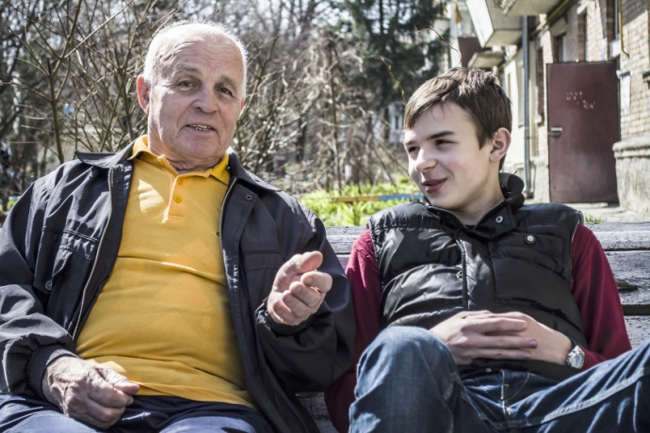

**Join River Hill High School PTSA and HC DrugFree**

…along with representatives from the Howard County Public School System, the Howard County State's Attorney's Office, the Howard County Police Department, treatment providers, parents with stories/wisdom to share, and others to gain powerful insights and answers to your questions.



**HC DrugFree 443-325-0040 Admin@hcdrugfree.org www.hcdrugfree.org.**