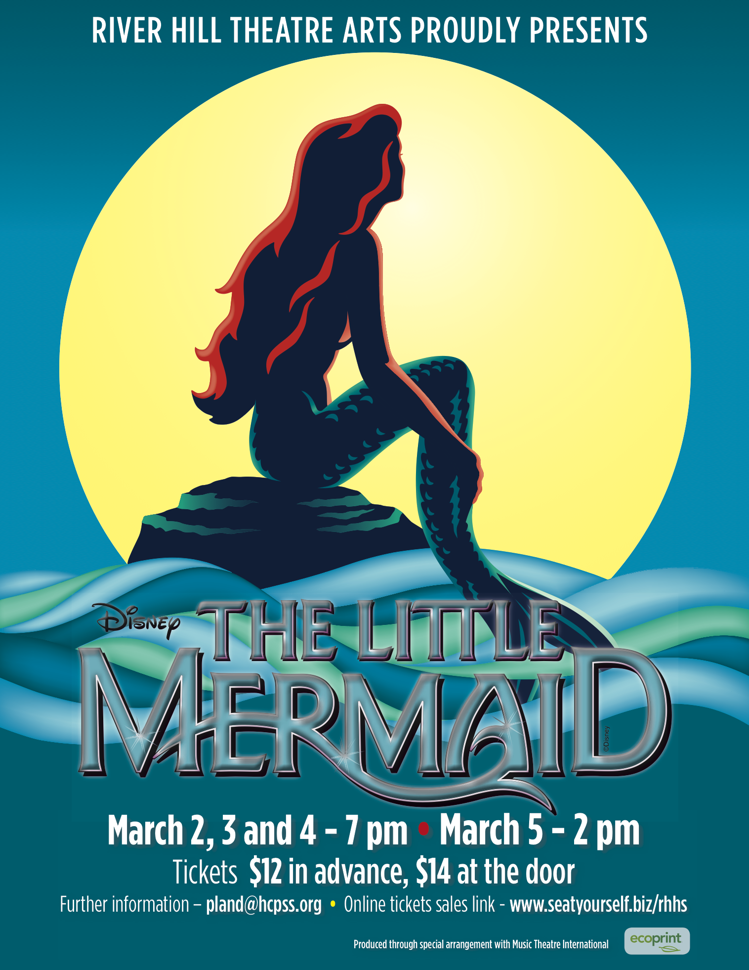

Disney’s The Little Mermaid- Press Release
River Hill Theatre Arts Department
Pam Land-Director
12101 Route 108, Clarksville, MD 21029
pland@hcpss.org or 410-313-7120

This March, the River Hill High School Theatre Arts Department will proudly present the Disney musical, The Little Mermaid. This show takes us to a magical underwater kingdom where the beautiful young mermaid Ariel longs to leave her ocean home behind and live in the world above. But first she’ll have to defy her father King Triton, make a deal with the evil sea witch Ursula, and convince the handsome Prince Eric that she’s the girl whose enchanting voice he’s been seeking. This production promises delights for children of all ages!

Produced, directed, and choreographed by RHHS Theatre Arts teacher Pam Land, the show is also co-choreographed by RHHS dance teacher, Jennifer Hennessie. Assisting as student directors are Julianne Blackman, Ashley Chen, and Lexxi Skochinski. Joe Blasko, a longtime friend of RHHS Theatre Arts, will direct the construction of the set with assistance from RHHS alumni parents George Stone and Bob Bost. A crew of more than 30 dedicated students led by student stage managers, R.J. O’Brien and Autumn Mack, will build the set and props and run the show. RHHS vocal music teacher, Katie Geiger, will direct the vocals and prepare the student orchestra. RHHS math teacher Rhonda De La Mar will design costumes with the assistance of a wonderful team of parent volunteers.

The cast of more than 60 RHHS students includes Annie Maloney as “Ariel”, Austin Abraham as “Prince Eric”, Danielle Gover as “Flounder”, Nikoo Sarraf as “Scuttle”, Josh Tow as “King Triton”, Jasmine Tiamfook as “Sebastian”, Tolu Faderin as “Ursula”, Anna Hovet as “Flotsam”, Joey Heitzmann as “Jetsam”, Thaddeus Harold as “Grimsby”, Kevin Key as “Chef Louis”, and Caroline Lovelace, Nina Esposito-Faraone, Ashleigh Steinberg, Ri Hyun Kim, Abby Swygert, and Megan Radcliffe as the “Mersisters”.

Performance dates and ticket information:
All performances will be held in the River Hill High School auditorium.
The performance dates are March 2,3, and 4 @ 7 p.m. and March 5 @ 2 p.m.
Tickets are $12 in advance and $14 at the door.

THE ADVANCE TICKET SALE PRICE ($12) WILL BE HONORED AT THE DOOR IF YOU BRING A NON-PERISHABLE FOOD ITEM. All food donations go to Howard County Food Bank.

Advance sale of tickets:
Online (now) via “Seat yourself” at http://www.seatyourself.biz/rhhs
- In Front of the RHHS Dining Hall- Monday, February 27 thru Friday, March 3 (10:30 a.m.-12:30 p.m.)
- Box Office (opens 90 minutes before curtain)

If you have questions or need further information, contact Pam Land at pland@hcpss.org or 410-313-7120.

